APPENDIX

Appendix 1.
Tabel 1. Organizational Culture Operational Variabel
(Source : Robbins dan Judge, 2015)
Dimension | Indicator | Operational
Basic Value | Innovation and risk taking | The company values the participation and willingness of employees to experiment with new ideas
Basic Value | Pay attention to details | The company encourages employees to analyze in detail and precision on every job handled
Basic Value | Aggressiveness | The company encourages employees to be aggressive and competitive in terms of company progress
Basic Value | Stability | The company encourages employees to maintain good conditions in the company today
Organizational Orientation | Orientation on results | The company believes that the final result is the most important and needed
Organizational Orientation | Orientation in people | The company always considers every effect of the end result that will have an impact on employees
Organizational Orientation | Team orientation | The company always encourages employees to work in teams rather than individuals

Tabel 2. Technology Transfer Operational Variabel
(Source: Kundu, N., Bhar, C., & Pandurangan, V, 2015)
Dimension | Indicator | Operational
Technical Tools | Technical compatibility | The transferor and recipient of the transfer have the appropriate equipment in the process of successful collaboration
Technical Tools | Environmental compatibility | The technology transferred has gone through an adjustment phase to the physical and social impacts of the transfer recipient
Technical Tools | Cultural compatibility | The technology transferred has the appropriate background and cultural basis between the transferor and recipient of the transfer
Technological process | Perception of technology | The company has gained knowledge and understanding of know how technology is used
Technological process | Perception of transfers | Technology transfer by the transferor according to the needs and development of the company's business
Technological process | Transfer Readiness | The company has made good preparations to unite the transferor and recipient of the transfer in terms of time and thought, the same technological vision, language and documents used, as well as mental readiness about the global technological system
Knowledge | Learning | The transferor has a willingness to transfer technology and is welcomed by a willingness and enthusiasm to learn from the recipient of the transfer
Knowledge | Technology management | The company has and applies a good change management system to address the process of change in the company due to technology transfer practices
Organization | Technology transfer agreement | The company has an agreement or contract of work between the transferor and recipient of the transfer which contains four important elements of scope, confidentiality, termination and arbitration
Organization | Social network | The company actively collaborates with other parties to overcome new technological changes and the speed of technology development

Tabel 3. Company Performance Operational Variabel
(Source : Valmohammadi dan Roshanzamir, 2014)
Dimension | Indicator | Operational
Operational performance | Productivity | Over the past 3 years, the achievement of company productivity exceeded the given target
Operational performance | Innovation Process | Over the past 3 years, the achievement of improvement and innovation process has reached the implementation target and is still being used until now
Customer satisfaction and involvement | Quality | Over the past 3 years, the company's reject ratio and customer claim achievements reached the given target
Customer satisfaction and involvement | Delivery | Over the past 3 years, the achievement of the company's delivery performance has met the given target
Labor climate | Safety | Over the past 3 years, the achievement of the company's work accident index performance met the given target
Labor climate | Healthy | Over the past 3 years, the achievement of employee health index through the results of medical check-ups has met the given target

Appendix 2. Smart PLS Running Models
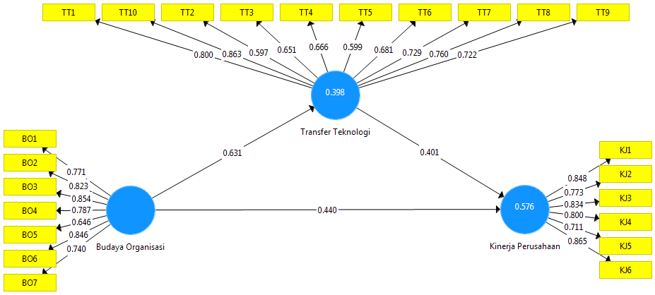
Figure 1. Construct Validity Analysis Results

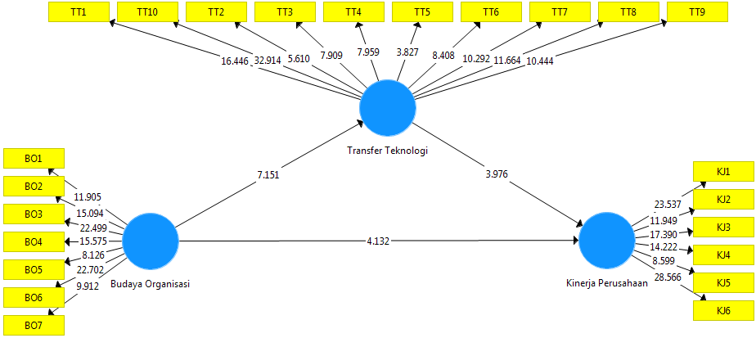
Figure 2. T Test Result

