Factor Analysis

KMO and Bartlett's Test
Kaiser-Meyer-Olkin Measure of Sampling Adequacy. |  | .886
Bartlett's Test of Sphericity | Approx. Chi-Square | 7033.395
Bartlett's Test of Sphericity | df | 1653
Bartlett's Test of Sphericity | Sig. | .000

Communalities
 | Initial | Extraction
LS1 | 1.000 | .351
LS2 | 1.000 | .346
LS3 | 1.000 | .295
LS4 | 1.000 | .327
LS5 | 1.000 | .372
LS6 | 1.000 | .332
LS7 | 1.000 | .288
LS8 | 1.000 | .368
LS9 | 1.000 | .415
LS10 | 1.000 | .409
LS11 | 1.000 | .393
LS12 | 1.000 | .398
OL1 | 1.000 | .360
OL2 | 1.000 | .395
OL3 | 1.000 | .471
OL4 | 1.000 | .446
OL5 | 1.000 | .398
OL6 | 1.000 | .479
OL7 | 1.000 | .544
OL8 | 1.000 | .487
OL9 | 1.000 | .475
OL10 | 1.000 | .482
OL11 | 1.000 | .436
OL12 | 1.000 | .510
OL13 | 1.000 | .378
OL14 | 1.000 | .370
OL15 | 1.000 | .363
OL16 | 1.000 | .329
OI1 | 1.000 | .369
OI2 | 1.000 | .279
OI3 | 1.000 | .322
OI4 | 1.000 | .384
OI5 | 1.000 | .376
OI6 | 1.000 | .283
OI7 | 1.000 | .397
OI8 | 1.000 | .430
OI9 | 1.000 | .288
OI10 | 1.000 | .272
OI11 | 1.000 | .305
OI12 | 1.000 | .459
OI13 | 1.000 | .417
OI14 | 1.000 | .407
OI15 | 1.000 | .470
OI16 | 1.000 | .426
OI17 | 1.000 | .330
OI18 | 1.000 | .349
OI19 | 1.000 | .435
OI20 | 1.000 | .419
OP1 | 1.000 | .410
OP2 | 1.000 | .401
OP3 | 1.000 | .403
OP4 | 1.000 | .444
OP5 | 1.000 | .425
OP6 | 1.000 | .491
OP7 | 1.000 | .456
OP8 | 1.000 | .460
OP9 | 1.000 | .436
OP10 | 1.000 | .398
Extraction Method: Principal Component Analysis.

Total Variance Explained
Component | Initial Eigenvalues |  |  | Extraction Sums of Squared Loadings |  |  | Rotation Sums of Squared Loadings
Component | Total | % of Variance | Cumulative % | Total | % of Variance | Cumulative % | Total | % of Variance | Cumulative %
1 | 10.875 | 18.750 | 18.750 | 10.875 | 18.750 | 18.750 | 7.389 | 12.740 | 12.740
2 | 6.242 | 10.762 | 29.512 | 6.242 | 10.762 | 29.512 | 6.939 | 11.964 | 24.704
3 | 3.339 | 5.757 | 35.269 | 3.339 | 5.757 | 35.269 | 4.393 | 7.574 | 32.279
4 | 2.499 | 4.308 | 39.578 | 2.499 | 4.308 | 39.578 | 4.233 | 7.299 | 39.578
5 | 1.373 | 2.367 | 41.945
6 | 1.278 | 2.204 | 44.148
7 | 1.237 | 2.132 | 46.280
8 | 1.226 | 2.113 | 48.394
9 | 1.168 | 2.014 | 50.408
10 | 1.108 | 1.911 | 52.319
11 | 1.064 | 1.834 | 54.153
12 | 1.061 | 1.830 | 55.983
13 | .994 | 1.714 | 57.696
14 | .969 | 1.671 | 59.367
15 | .958 | 1.651 | 61.019
16 | .916 | 1.579 | 62.598
17 | .897 | 1.546 | 64.144
18 | .864 | 1.490 | 65.634
19 | .842 | 1.451 | 67.085
20 | .810 | 1.396 | 68.481
21 | .787 | 1.356 | 69.837
22 | .780 | 1.345 | 71.182
23 | .767 | 1.322 | 72.504
24 | .738 | 1.272 | 73.776
25 | .715 | 1.233 | 75.009
26 | .710 | 1.224 | 76.233
27 | .674 | 1.161 | 77.394
28 | .663 | 1.143 | 78.537
29 | .650 | 1.120 | 79.657
30 | .635 | 1.095 | 80.752
31 | .596 | 1.028 | 81.779
32 | .592 | 1.021 | 82.800
33 | .576 | .993 | 83.793
34 | .547 | .944 | 84.736
35 | .534 | .921 | 85.657
36 | .513 | .884 | 86.541
37 | .504 | .868 | 87.409
38 | .492 | .848 | 88.257
39 | .476 | .821 | 89.078
40 | .459 | .791 | 89.869
41 | .445 | .767 | 90.636
42 | .438 | .755 | 91.392
43 | .413 | .712 | 92.104
44 | .395 | .682 | 92.785
45 | .375 | .646 | 93.431
46 | .371 | .640 | 94.071
47 | .365 | .629 | 94.700
48 | .352 | .606 | 95.306
49 | .337 | .580 | 95.886
50 | .320 | .551 | 96.438
51 | .308 | .531 | 96.969
52 | .289 | .498 | 97.467
53 | .269 | .463 | 97.930
54 | .262 | .452 | 98.382
55 | .259 | .446 | 98.829
56 | .249 | .429 | 99.257
57 | .217 | .375 | 99.632
58 | .214 | .368 | 100.000
Extraction Method: Principal Component Analysis.

Component Matrixª
 | Component
 | 1 | 2 | 3 | 4
LS1
LS2
LS3
LS4
LS5
LS6
LS7
LS8
LS9 |  |  | .516
LS10 |  |  | .512
LS11 |  |  | .509
LS12 |  |  | .528
OL1
OL2
OL3 |  | .554
OL4
OL5
OL6
OL7 |  | .537
OL8
OL9
OL10 |  | .514
OL11
OL12 |  | .521
OL13
OL14
OL15
OL16
OI1
OI2
OI3
OI4
OI5
OI6
OI7 | .503
OI8
OI9
OI10
OI11
OI12 | .521
OI13 | .522
OI14
OI15
OI16 | .505
OI17
OI18
OI19 | .503
OI20
OP1
OP2
OP3
OP4
OP5 | .538
OP6 | .510
OP7
OP8
OP9
OP10
Extraction Method: Principal Component Analysis.
a. 4 components extracted.

Rotated Component Matrixª
 | Component
 | 1 | 2 | 3 | 4
LS1 |  |  | .555
LS2 |  |  | .568
LS3 |  |  | .522
LS4 |  |  | .542
LS5 |  |  | .586
LS6 |  |  | .556
LS7 |  |  | .521
LS8 |  |  | .589
LS9 |  |  | .623
LS10 |  |  | .611
LS11 |  |  | .609
LS12 |  |  | .619
OL1 |  | .570
OL2 |  | .612
OL3 |  | .657
OL4 |  | .654
OL5 |  | .623
OL6 |  | .673
OL7 |  | .705
OL8 |  | .674
OL9 |  | .674
OL10 |  | .668
OL11 |  | .643
OL12 |  | .703
OL13 |  | .609
OL14 |  | .597
OL15 |  | .593
OL16 |  | .569
OI1 | .592
OI2 | .504
OI3 | .553
OI4 | .589
OI5 | .596
OI6 | .511
OI7 | .580
OI8 | .634
OI9 | .533
OI10 | .503
OI11 | .537
OI12 | .648
OI13 | .607
OI14 | .625
OI15 | .669
OI16 | .636
OI17 | .529
OI18 | .579
OI19 | .635
OI20 | .644
OP1 |  |  |  | .587
OP2 |  |  |  | .589
OP3 |  |  |  | .589
OP4 |  |  |  | .616
OP5 |  |  |  | .568
OP6 |  |  |  | .657
OP7 |  |  |  | .640
OP8 |  |  |  | .641
OP9 |  |  |  | .611
OP10 |  |  |  | .588
Extraction Method: Principal Component Analysis.
Rotation Method: Varimax with Kaiser Normalization.
a. Rotation converged in 5 iterations.

Component Transformation Matrix
Component | 1 | 2 | 3 | 4
1 | .628 | .515 | .375 | .447
2 | -.644 | .765 | .011 | .014
3 | -.207 | -.183 | .922 | -.273
4 | .385 | .341 | -.098 | -.852
Extraction Method: Principal Component Analysis.
Rotation Method: Varimax with Kaiser Normalization.

Reliability

Scale: ALL VARIABLES

Case Processing Summary
 |  | N | %
Cases | Valid | 320 | 100.0
Cases | Excludedª | 0 | .0
Cases | Total | 320 | 100.0
a. Listwise deletion based on all variables in the procedure.

Reliability Statistics
Cronbach's Alpha | N of Items
.833 | 12

Item-Total Statistics
 | Scale Mean if Item Deleted | Scale Variance if Item Deleted | Corrected Item-Total Correlation | Cronbach's Alpha if Item Deleted
LS1 | 43.0594 | 22.043 | .490 | .820
LS2 | 43.0437 | 22.067 | .490 | .820
LS3 | 43.0562 | 22.599 | .437 | .824
LS4 | 43.0719 | 22.318 | .471 | .822
LS5 | 43.1031 | 22.112 | .497 | .820
LS6 | 43.0219 | 21.871 | .481 | .821
LS7 | 43.0750 | 22.427 | .437 | .825
LS8 | 43.0687 | 22.165 | .506 | .819
LS9 | 43.0344 | 21.920 | .540 | .817
LS10 | 43.0687 | 21.945 | .521 | .818
LS11 | 43.0219 | 21.846 | .506 | .819
LS12 | 43.1000 | 21.996 | .517 | .818

Reliability

Scale: ALL VARIABLES

Case Processing Summary
 |  | N | %
Cases | Valid | 320 | 100.0
Cases | Excludedª | 0 | .0
Cases | Total | 320 | 100.0
a. Listwise deletion based on all variables in the procedure.

Reliability Statistics
Cronbach's Alpha | N of Items
.909 | 16

Item-Total Statistics
 | Scale Mean if Item Deleted | Scale Variance if Item Deleted | Corrected Item-Total Correlation | Cronbach's Alpha if Item Deleted
OL1 | 59.2313 | 33.056 | .531 | .906
OL2 | 59.2125 | 33.158 | .564 | .905
OL3 | 59.2531 | 33.356 | .609 | .903
OL4 | 59.2750 | 33.285 | .597 | .904
OL5 | 59.2406 | 33.312 | .567 | .905
OL6 | 59.3094 | 32.948 | .633 | .903
OL7 | 59.3156 | 32.800 | .681 | .901
OL8 | 59.3125 | 32.817 | .637 | .902
OL9 | 59.3156 | 32.674 | .630 | .903
OL10 | 59.2781 | 32.885 | .631 | .903
OL11 | 59.2750 | 32.758 | .598 | .904
OL12 | 59.3000 | 32.662 | .653 | .902
OL13 | 59.2781 | 33.462 | .546 | .905
OL14 | 59.2594 | 33.296 | .547 | .905
OL15 | 59.2719 | 33.434 | .538 | .906
OL16 | 59.2938 | 33.468 | .510 | .907

Reliability

Scale: ALL VARIABLES

Case Processing Summary
 |  | N | %
Cases | Valid | 320 | 100.0
Cases | Excludedª | 0 | .0
Cases | Total | 320 | 100.0
a. Listwise deletion based on all variables in the procedure.

Reliability Statistics
Cronbach's Alpha | N of Items
.906 | 20

Item-Total Statistics
 | Scale Mean if Item Deleted | Scale Variance if Item Deleted | Corrected Item-Total Correlation | Cronbach's Alpha if Item Deleted
OI1 | 76.8094 | 53.120 | .542 | .902
OI2 | 76.8094 | 53.440 | .472 | .903
OI3 | 76.7969 | 53.498 | .508 | .903
OI4 | 76.8062 | 53.135 | .554 | .901
OI5 | 76.7344 | 52.829 | .554 | .901
OI6 | 76.7969 | 52.871 | .471 | .904
OI7 | 76.7281 | 52.731 | .566 | .901
OI8 | 76.7469 | 52.666 | .599 | .900
OI9 | 76.7281 | 53.547 | .469 | .904
OI10 | 76.7844 | 53.417 | .451 | .904
OI11 | 76.7094 | 53.580 | .495 | .903
OI12 | 76.7281 | 52.763 | .614 | .900
OI13 | 76.7188 | 52.303 | .588 | .900
OI14 | 76.7656 | 52.456 | .579 | .901
OI15 | 76.7625 | 52.489 | .628 | .900
OI16 | 76.7531 | 52.663 | .593 | .900
OI17 | 76.7656 | 52.863 | .511 | .903
OI18 | 76.7531 | 52.299 | .526 | .902
OI19 | 76.7531 | 52.324 | .599 | .900
OI20 | 76.8094 | 52.456 | .568 | .901

Reliability

Scale: ALL VARIABLES

Case Processing Summary
 |  | N | %
Cases | Valid | 320 | 100.0
Cases | Excludedª | 0 | .0
Cases | Total | 320 | 100.0
a. Listwise deletion based on all variables in the procedure.

Reliability Statistics
Cronbach's Alpha | N of Items
.852 | 10

Item-Total Statistics
 | Scale Mean if Item Deleted | Scale Variance if Item Deleted | Corrected Item-Total Correlation | Cronbach's Alpha if Item Deleted
OP1 | 35.8531 | 11.731 | .548 | .838
OP2 | 35.8625 | 11.768 | .535 | .840
OP3 | 35.8781 | 11.831 | .528 | .840
OP4 | 35.8250 | 11.693 | .562 | .837
OP5 | 35.8438 | 11.537 | .558 | .838
OP6 | 35.8313 | 11.727 | .590 | .835
OP7 | 35.8594 | 11.676 | .564 | .837
OP8 | 35.8625 | 11.580 | .567 | .837
OP9 | 35.8750 | 11.658 | .559 | .837
OP10 | 35.8469 | 11.603 | .525 | .841

Descriptives

Descriptive Statistics
 | N | Minimum | Maximum | Mean | Std. Deviation
Transactional Leadership | 320 | 2.20 | 5.00 | 3.9081 | .46997
Transformational Leadership | 320 | 2.00 | 5.00 | 3.9192 | .46243
management commitmen | 320 | 2.00 | 5.00 | 3.9856 | .42483
system perspective | 320 | 2.00 | 5.00 | 3.9272 | .43648
openness and experimentation | 320 | 2.00 | 5.00 | 3.9594 | .49755
knowledge transfer and integration | 320 | 2.00 | 5.00 | 3.9453 | .53202
product innovation | 320 | 2.00 | 5.00 | 3.9937 | .52220
market innovation | 320 | 2.00 | 5.00 | 4.0349 | .42240
behavior innovation | 320 | 2.00 | 5.00 | 4.0625 | .45207
strategy innovation | 320 | 2.00 | 5.00 | 4.0542 | .44638
process innovation | 320 | 2.00 | 5.00 | 4.0312 | .51355
Eksternal | 320 | 2.00 | 5.00 | 3.9850 | .41024
Internal | 320 | 2.00 | 5.00 | 3.9825 | .41832
Valid N (listwise) | 320

Descriptives

Descriptive Statistics
 | N | Minimum | Maximum | Mean | Std. Deviation
Leadership Style | 320 | 2.10 | 5.00 | 3.9137 | .42370
Organizational Learning | 320 | 2.00 | 5.00 | 3.9544 | .38333
Organizational Innovation | 320 | 2.62 | 4.71 | 3.9807 | .26809
Organizational Performance | 320 | 2.00 | 5.00 | 3.9837 | .37665
Valid N (listwise) | 320

Correlations
Correlations
 |  | Leadership Style | Organizational Learning | Organizational Innovation | Organizational Performance
Leadership Style | Pearson Correlation | 1 | .247** | .652** | .282**
Leadership Style | Sig. (1-tailed) |  | .000 | .000 | .000
Leadership Style | N | 320 | 320 | 320 | 320
Organizational Learning | Pearson Correlation | .247** | 1 | .621** | .362**
Organizational Learning | Sig. (1-tailed) | .000 |  | .000 | .000
Organizational Learning | N | 320 | 320 | 320 | 320
Organizational Innovation | Pearson Correlation | .652** | .621** | 1 | .676**
Organizational Innovation | Sig. (1-tailed) | .000 | .000 |  | .000
Organizational Innovation | N | 320 | 320 | 320 | 320
Organizational Performance | Pearson Correlation | .282** | .362** | .676** | 1
Organizational Performance | Sig. (1-tailed) | .000 | .000 | .000
Organizational Performance | N | 320 | 320 | 320 | 320
**. Correlation is significant at the 0.01 level (1-tailed).

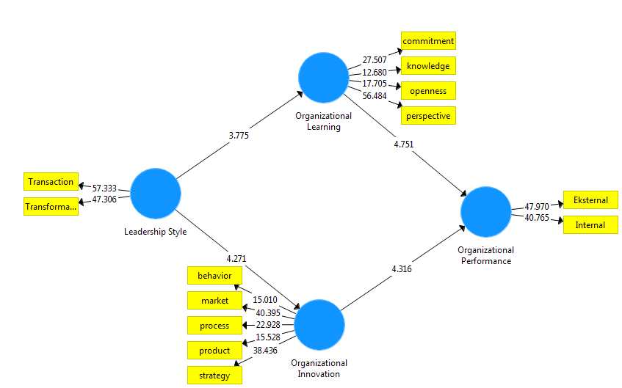

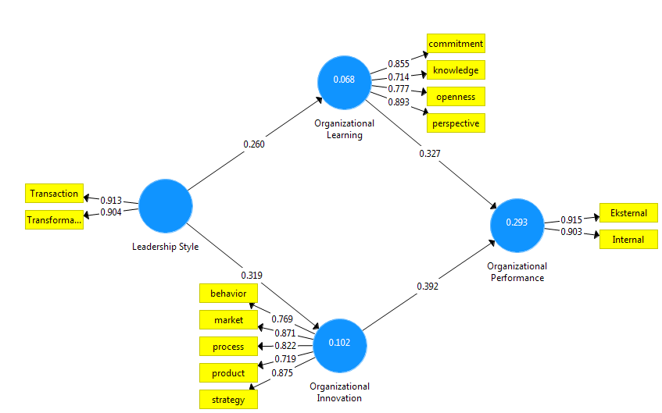

Final Results

Path Coefficients
- Mean, STDEV, T-Values, P-Values
- Confidence Intervals
- Confidence Intervals Bias Corrected
- Samples
 | Original Sample (O) | Sample Mean (M) | Standard Deviation (STDEV) | T Statistics (|O/STDEV|) | P Values
Leadership Style -> Organizational Innovation | 0.319 | 0.328 | 0.075 | 4.271 | 0.000
Leadership Style -> Organizational Learning | 0.260 | 0.262 | 0.069 | 3.775 | 0.000
Organizational Innovation -> Organizational Performance | 0.392 | 0.388 | 0.091 | 4.316 | 0.000
Organizational Learning -> Organizational Performance | 0.327 | 0.324 | 0.069 | 4.751 | 0.000

Total Indirect Effects
- Mean, STDEV, T-Values, P-Values
- Confidence Intervals
- Confidence Intervals Bias Corrected
- Samples
 | Original Sample (O) | Sample Mean (M) | Standard Deviation (STDEV) | T Statistics (|O/STDEV|) | P Values
Leadership Style -> Organizational Innovation
Leadership Style -> Organizational Learning
Leadership Style -> Organizational Performance | 0.210 | 0.216 | 0.050 | 4.233 | 0.000
Organizational Innovation -> Organizational Performance
Organizational Learning -> Organizational Performance

Specific Indirect Effects
- Mean, STDEV, T-Values, P-Values
- Confidence Intervals
- Confidence Intervals Bias Corrected
- Samples
 | Original Sample (O) | Sample Mean (M) | Standard Deviation (STDEV) | T Statistics (|O/STDEV|) | P Values
Leadership Style -> Organizational Innovation -> Organizational Performance | 0.125 | 0.130 | 0.049 | 2.571 | 0.010
Leadership Style -> Organizational Learning -> Organizational Performance | 0.085 | 0.087 | 0.034 | 2.506 | 0.013

Total Effects
- Mean, STDEV, T-Values, P-Values
- Confidence Intervals
- Confidence Intervals Bias Corrected
- Samples
 | Original Sample (O) | Sample Mean (M) | Standard Deviation (STDEV) | T Statistics (|O/STDEV|) | P Values
Leadership Style -> Organizational Innovation | 0.319 | 0.328 | 0.075 | 4.271 | 0.000
Leadership Style -> Organizational Learning | 0.260 | 0.262 | 0.069 | 3.775 | 0.000
Leadership Style -> Organizational Performance | 0.210 | 0.216 | 0.050 | 4.233 | 0.000
Organizational Innovation -> Organizational Performance | 0.392 | 0.388 | 0.091 | 4.316 | 0.000
Organizational Learning -> Organizational Performance | 0.327 | 0.324 | 0.069 | 4.751 | 0.000

Outer Loadings
- Mean, STDEV, T-Values, P-Values
- Confidence Intervals
- Confidence Intervals Bias Corrected
- Samples
 | Original Sample (O) | Sample Mean (M) | Standard Deviation (STDEV) | T Statistics (|O/STDEV|) | P Values
Eksternal <- Organizational Performance | 0.915 | 0.912 | 0.019 | 47.970 | 0.000
Internal <- Organizational Performance | 0.903 | 0.902 | 0.022 | 40.765 | 0.000
Transaction <- Leadership Style | 0.913 | 0.912 | 0.016 | 57.333 | 0.000
Transformation <- Leadership Style | 0.904 | 0.904 | 0.019 | 47.306 | 0.000
behavior <- Organizational Innovation | 0.769 | 0.763 | 0.051 | 15.010 | 0.000
commitment <- Organizational Learning | 0.855 | 0.854 | 0.031 | 27.507 | 0.000
knowledge <- Organizational Learning | 0.714 | 0.707 | 0.056 | 12.680 | 0.000
market <- Organizational Innovation | 0.871 | 0.869 | 0.022 | 40.395 | 0.000
openness <- Organizational Learning | 0.777 | 0.772 | 0.044 | 17.705 | 0.000
perspective <- Organizational Learning | 0.893 | 0.895 | 0.016 | 56.484 | 0.000
process <- Organizational Innovation | 0.822 | 0.816 | 0.036 | 22.928 | 0.000
product <- Organizational Innovation | 0.719 | 0.715 | 0.046 | 15.528 | 0.000
strategy <- Organizational Innovation | 0.875 | 0.873 | 0.023 | 38.436 | 0.000

Quality Criteria

R Square
 | R Square | R Square Adjusted
Organizational Innovation | 0.102 | 0.099
Organizational Learning | 0.068 | 0.065
Organizational Performance | 0.293 | 0.289

R Square charts
- R Square
- R Square Adjusted
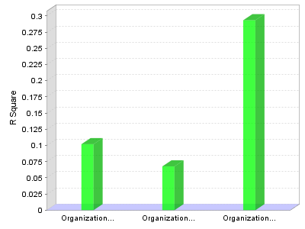

Construct Reliability and Validity
 | Cronbach's Alpha | rho_A | Composite Reliability | Average Variance Extracted (AVE)
Leadership Style | 0.789 | 0.790 | 0.905 | 0.826
Organizational Innovation | 0.871 | 0.889 | 0.907 | 0.662
Organizational Learning | 0.829 | 0.865 | 0.885 | 0.660
Organizational Performance | 0.790 | 0.792 | 0.905 | 0.826

Construct Reliability and Validity charts
- Cronbach's Alpha
- rho_A
- Composite Reliability
- Average Variance Extracted (AVE)
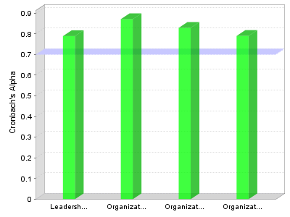

Discriminant Validity
- Fornell-Larcker Criterion
- Cross Loadings
- Heterotrait-Monotrait Ratio (HTMT)
 | Leadership Style | Organizational Innovation | Organizational Learning | Organizational Performance
Leadership Style | 0.909
Organizational Innovation | 0.319 | 0.814
Organizational Learning | 0.260 | 0.127 | 0.813
Organizational Performance | 0.283 | 0.434 | 0.377 | 0.909

Discriminant Validity
- Fornell-Larcker Criterion
- Cross Loadings
- Heterotrait-Monotrait Ratio (HTMT)

Outer Loadings
 | Leadership Style | Organizational Innovation | Organizational Learning | Organizational Performance
Eksternal |  |  |  | 0.915
Internal |  |  |  | 0.903
Transaction | 0.913
Transformation | 0.904
behavior |  | 0.769
commitment |  |  | 0.855
knowledge |  |  | 0.714
market |  | 0.871
openness |  |  | 0.777
perspective |  |  | 0.893
process |  | 0.822
product |  | 0.719
strategy |  | 0.875

Discriminant Validity charts
